From your BlackBoard course, find your assignment. Assignments are identified by the icon shown here. |  | 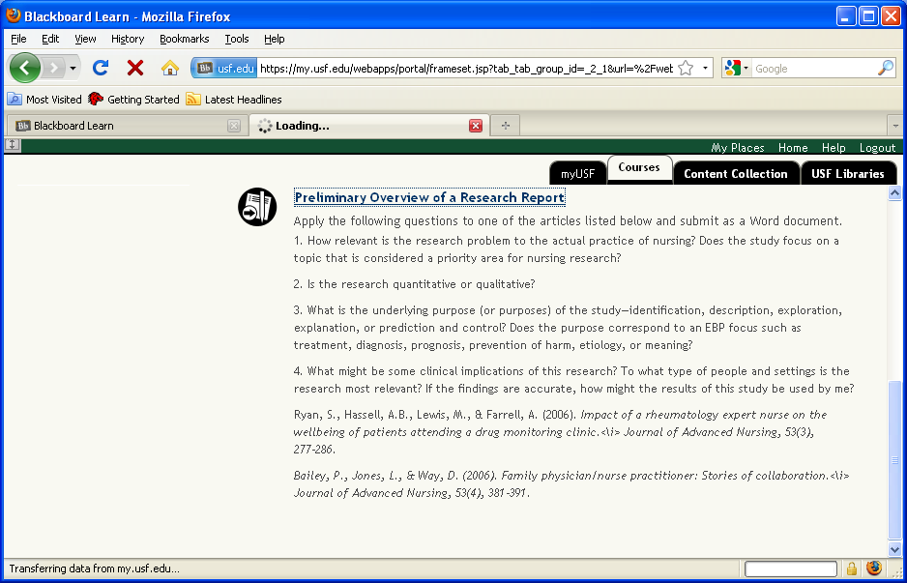
The assignment displays with the instructions. You can review the assignment and click Cancel or submit your assignment. |  | 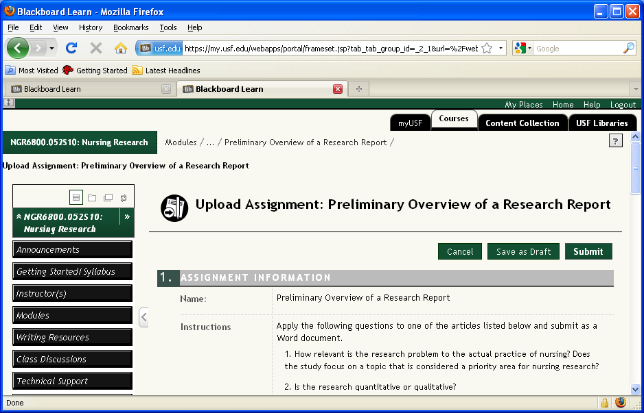
To submit an assignment, scroll down to the Attach File option. | 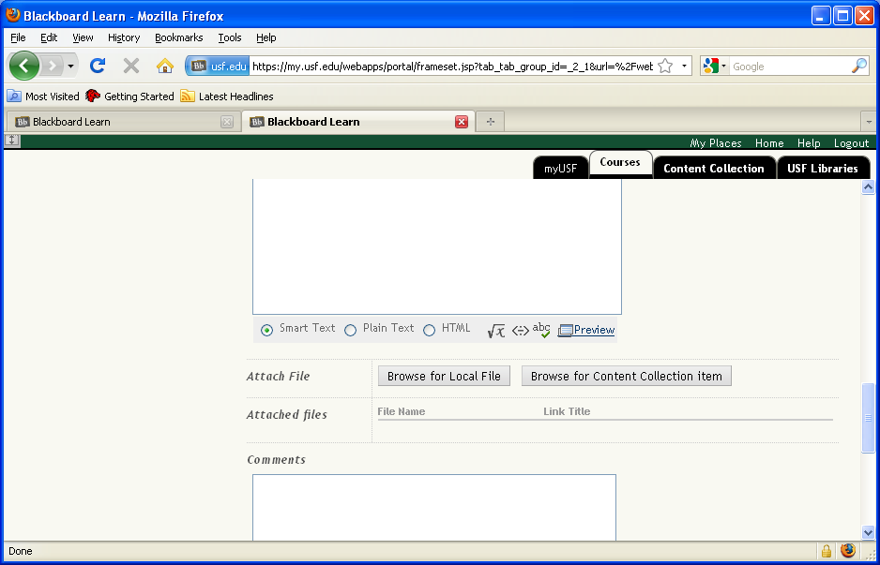
The File Upload window displays showing you the contents of your computer, select the file you are uploading and click Open. |  | 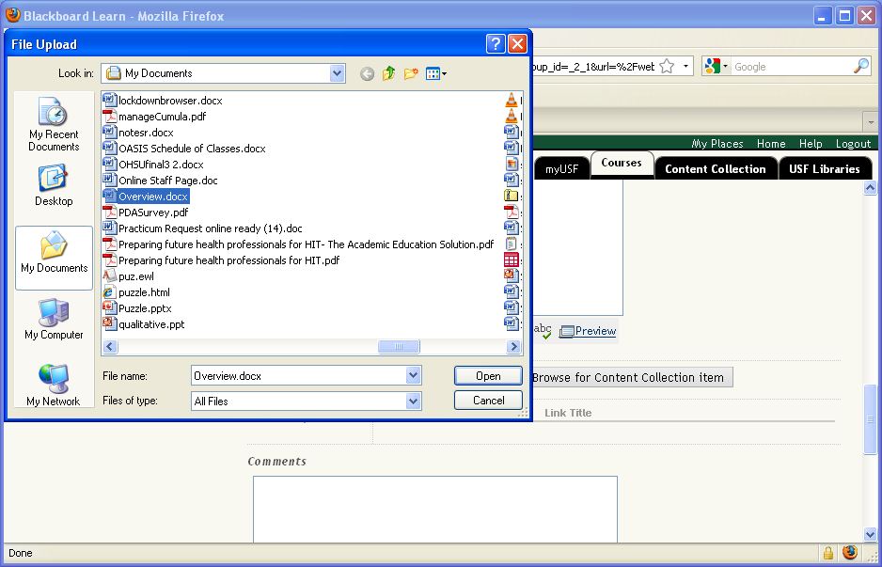
The file name displays, however, it is not attached.  To attach the file, click the Attach File button. |  | 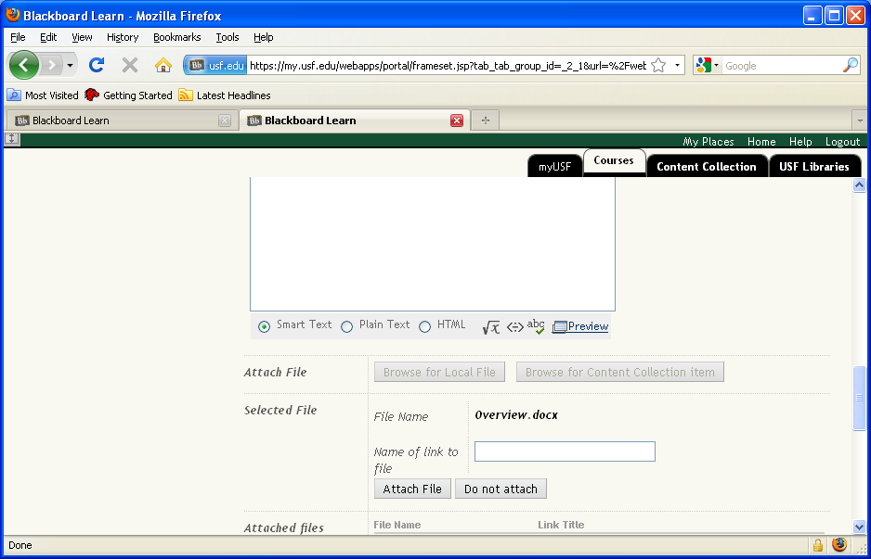
Note that the file is now identified as an attached file. |  | 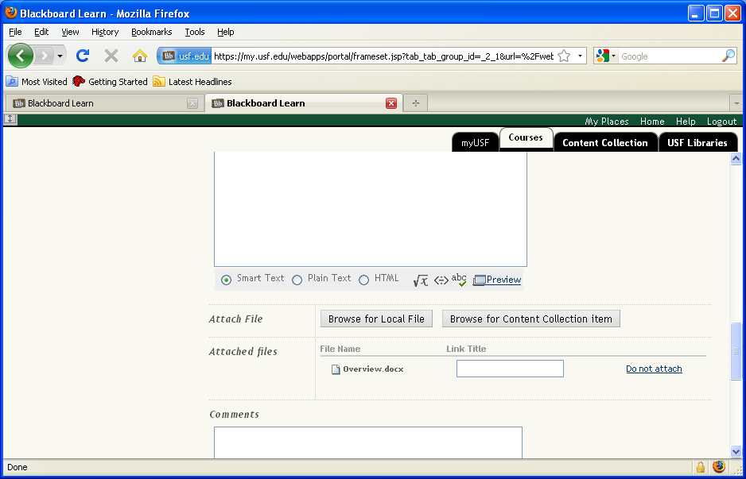
The last step to ensure your file is submitted, is to click the Submit button. If you click Save as Draft, your instructor will not be able to see the file. |  | 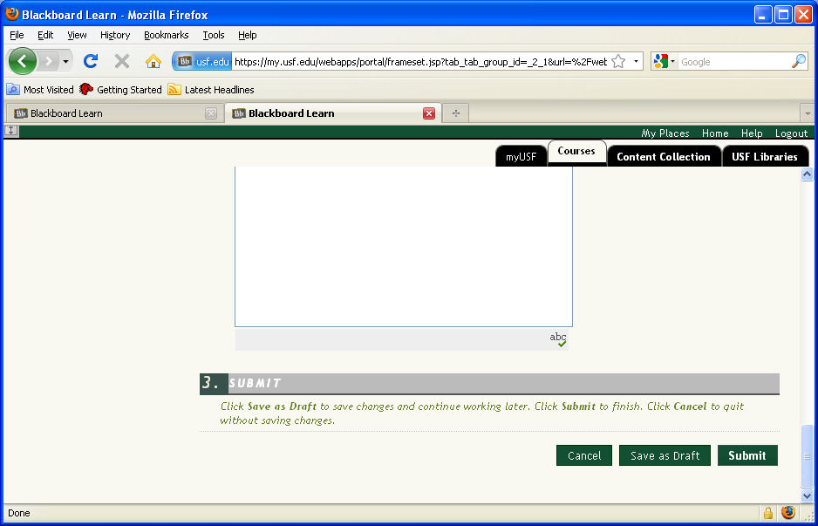
Click OK to exit the assignment submission process. |  | 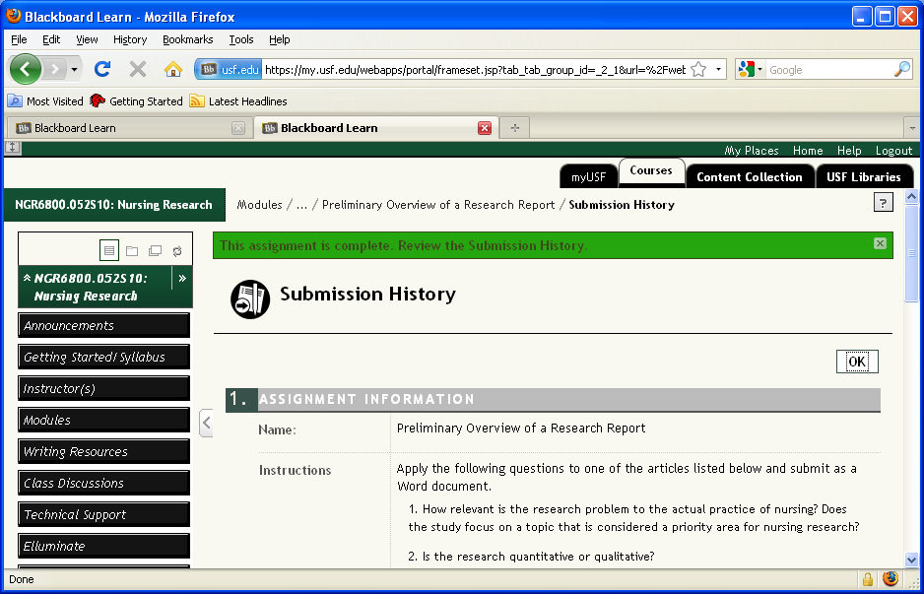
To ensure that you successfully submitted your assignment, click the Course Tools button. |  | 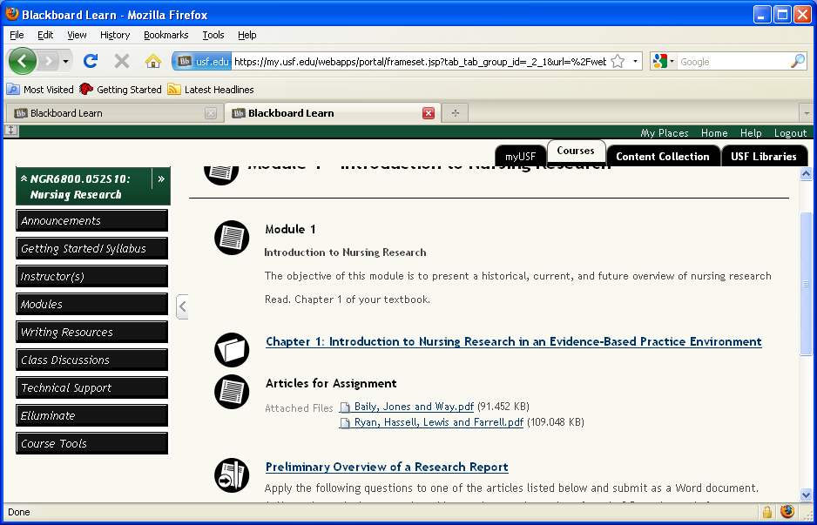
Select the My Grades link within Course Tools. |  | 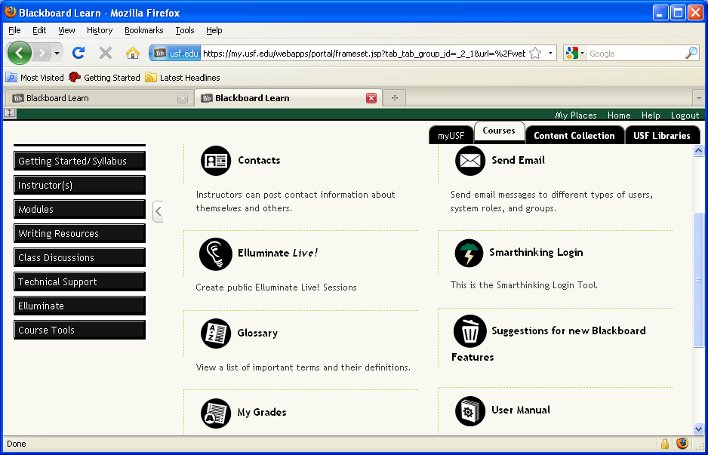
You can see in the grade book the green ! that indicates you submitted your assignment. However, to ensure your assignment actually uploaded, click the !. |  | 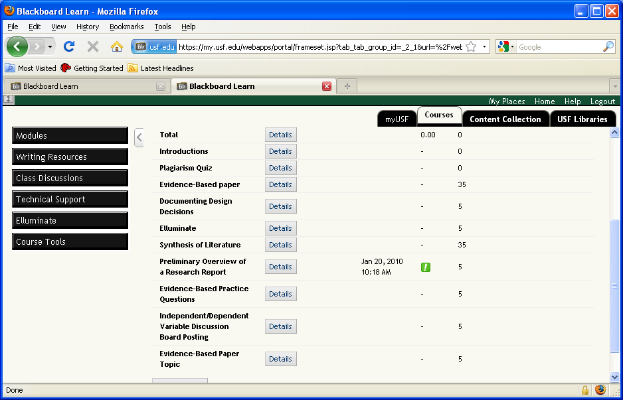
Your Submission History displays. |  | 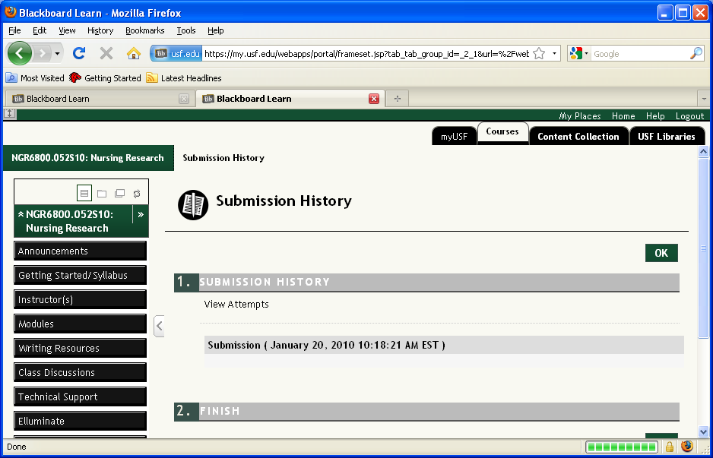
Scroll down until you see the Attached Files. If your file was uploaded, you can see it here.  If you need  additional help on  how to submit assignments, call USF IT at 813-974-1222. |  | 