**ADDING A DISCUSSION FORUM AND GRADING THE FORUM**

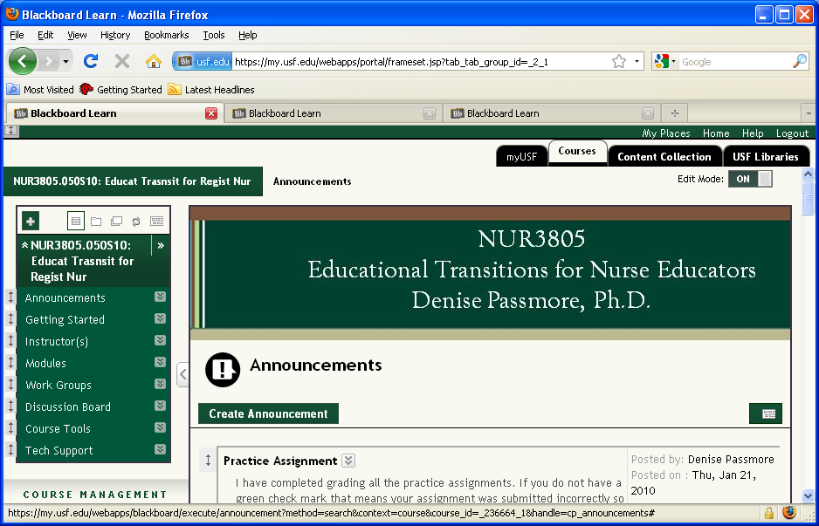

**Select Discussion Board**

**Slide 2 - Slide 2**

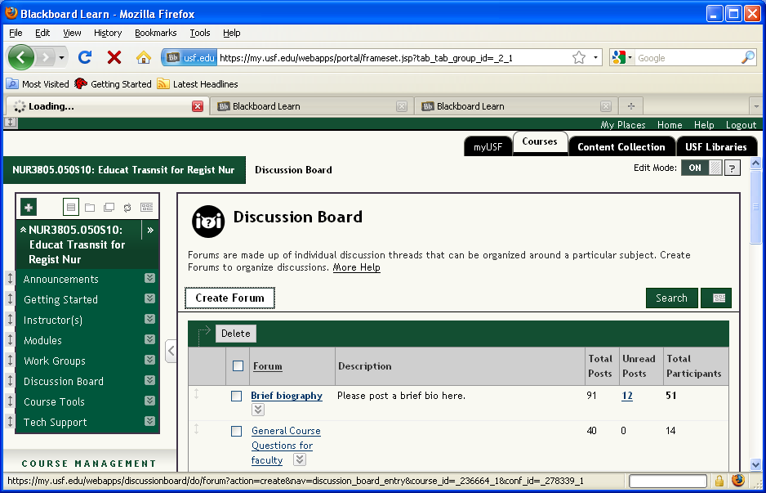

**To add a discussion board, click Create Forum**

**Slide 4 - Slide 4**

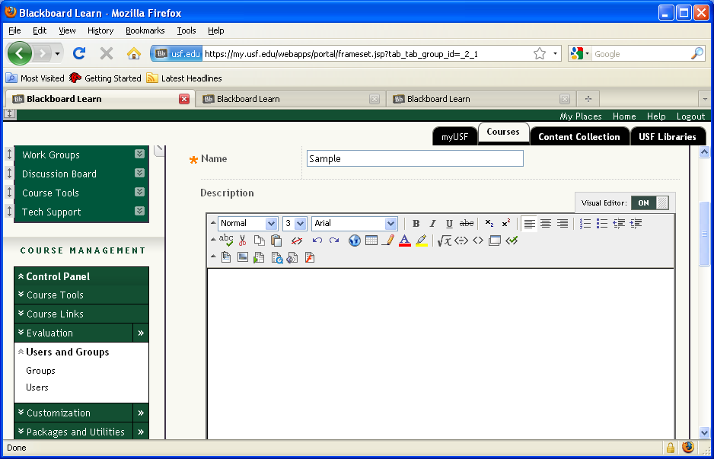

**Enter a Name and if desired, a Description of the discussion board.Slide 5 - Slide 5**

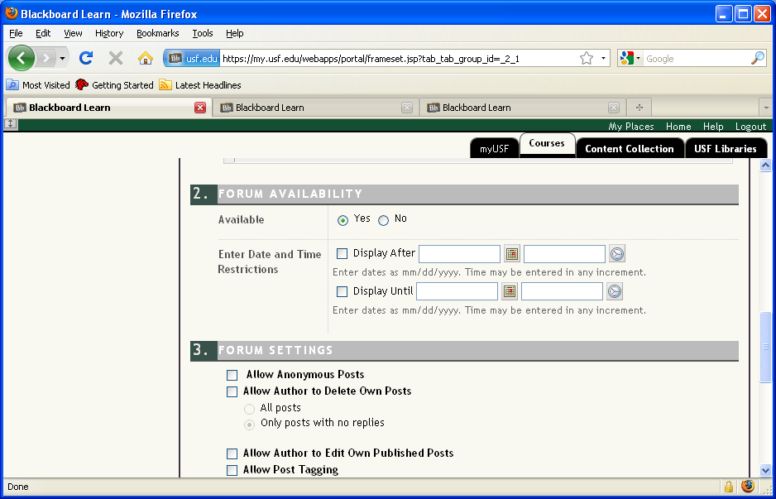

**If desired, enter Date and Time RestrictionsSlide 6 - Slide 6**

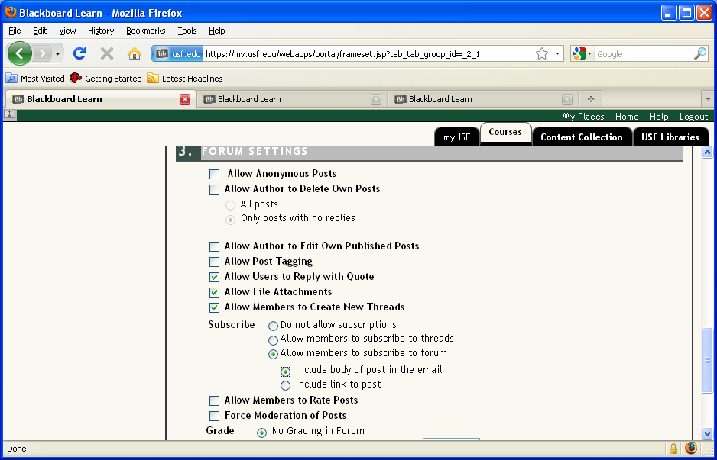

**If desired, allow members to subscribe to the forum. If this option is selected, users can choose to Subscribe to the forum. This is particularly useful for Q&A discussion boards so that you will be notified if there are questions.**

**Note that if this option is selected, a Subscribe button appears at the top of the forum. You can select this button to Subscribe. Once you do this, it will move to Unsubscribe. Slide 8 - Slide 8**

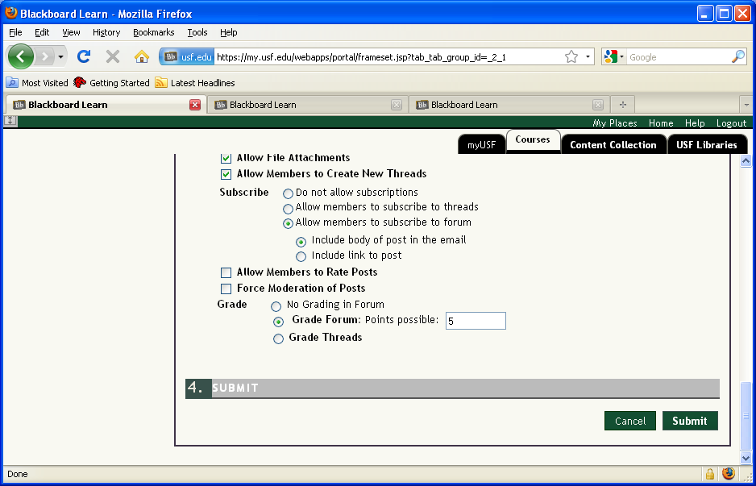

**If this is a graded discussion board, select Grade Forum and enter the points possible. This will then appear in the grade center. If you want it to be complete/incomplete only, enter a 0 here then adjust the entry in the grade center.Slide 9 - Slide 9**

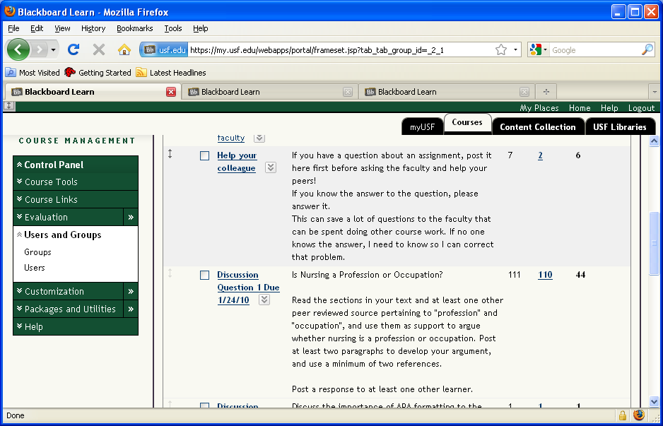

**To view and grade a forum, select the forum you are grading from the list of discussion boards.Slide 10 - Slide 10**

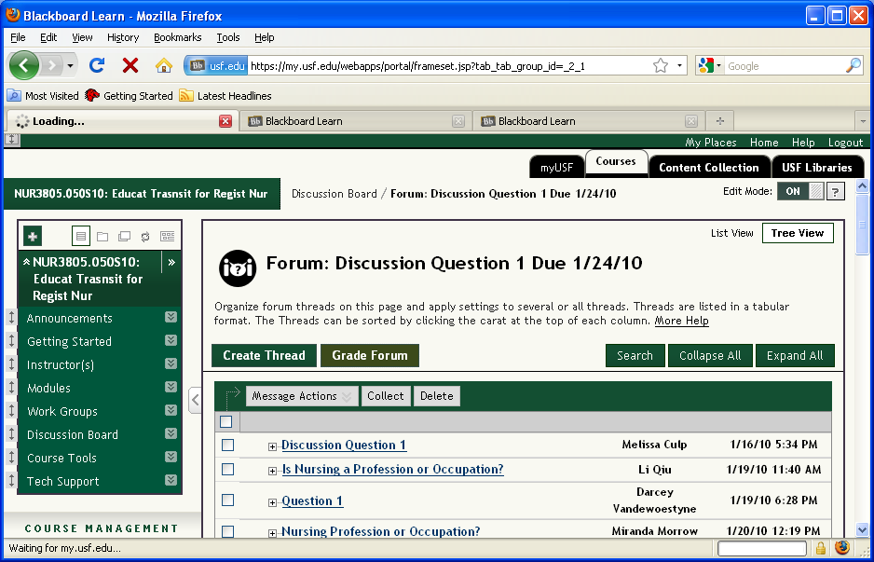

**Click Grade ForumSlide 11 - Slide 11**

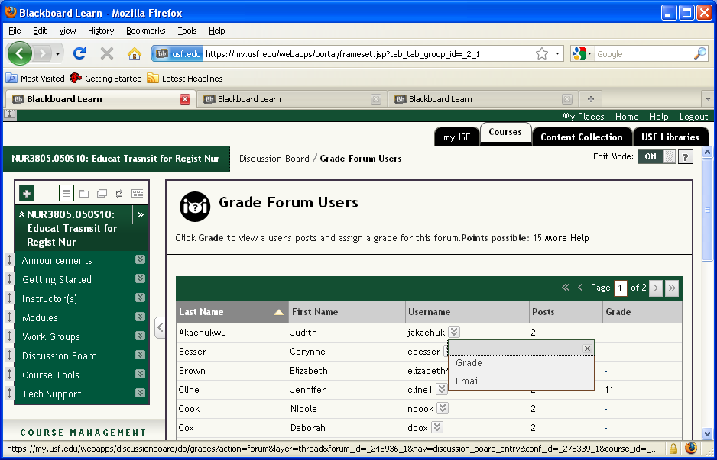

**Slide 12 - Slide 12**

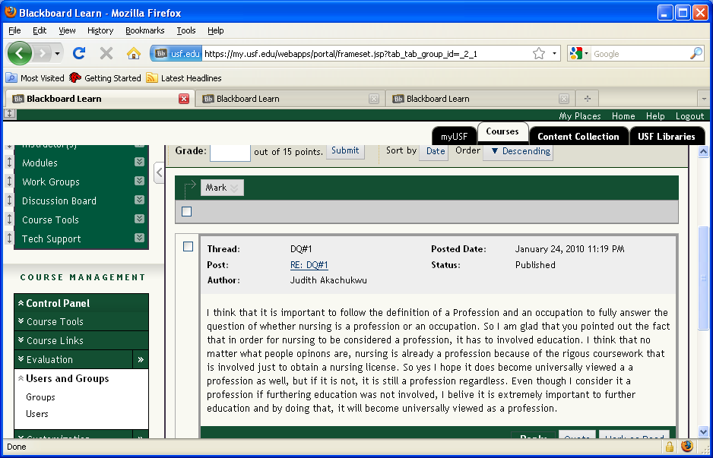

**All posts by the student display.Slide 13 - Slide 13**

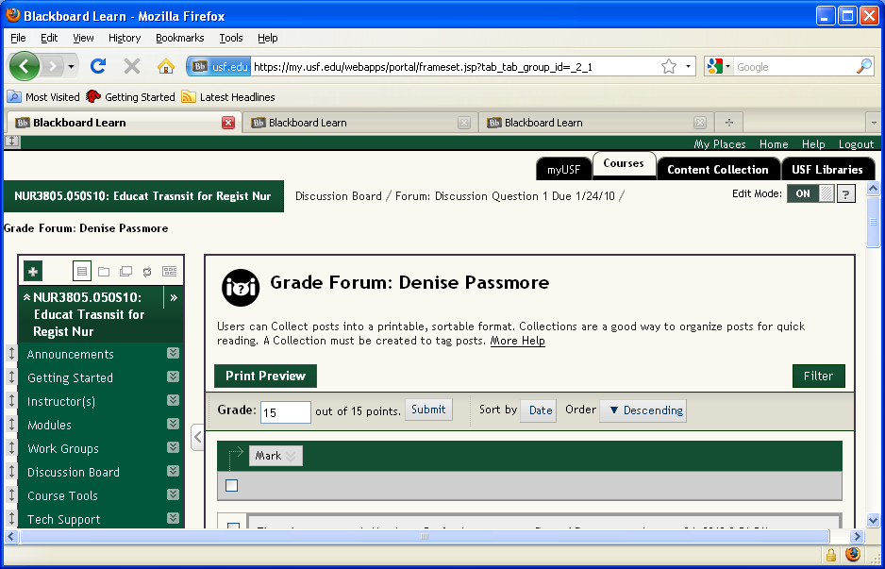

**Enter the grade for the student and click Submit.Slide 14 - Slide 14**

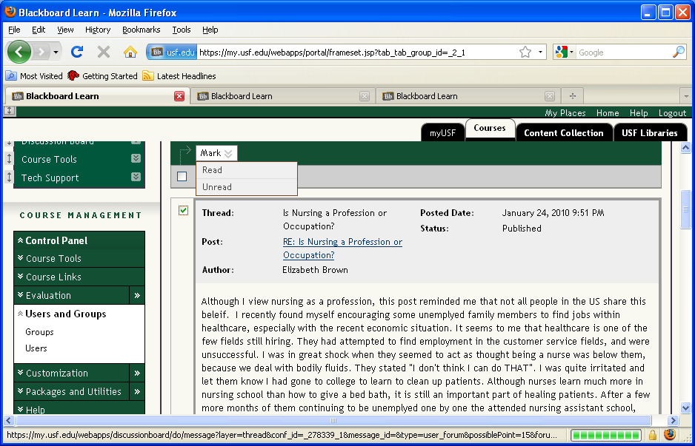

**To mark these posts as read, click the boxes next to each posting and then select Read from the Mark drop down box.SETTING AND AND USING SMART VIEWS**

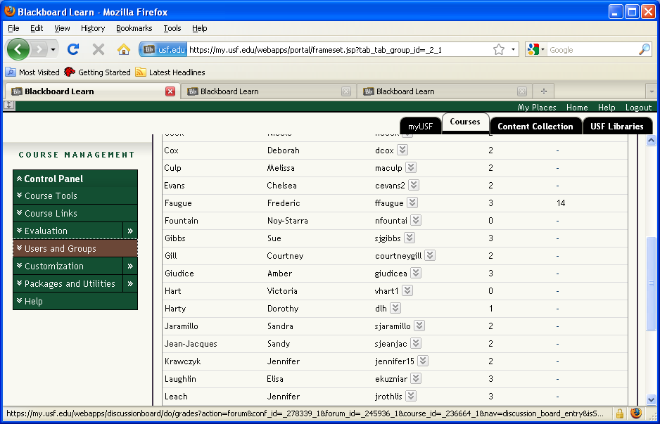

**From Course Management, select EvaluationSlide 16 - Slide 16**

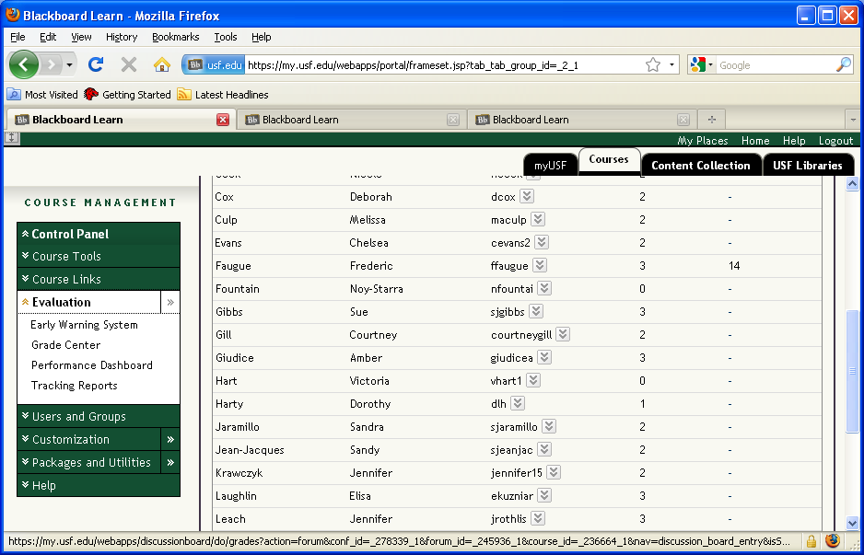

**Click Grade CenterSlide 17 - Slide 17**

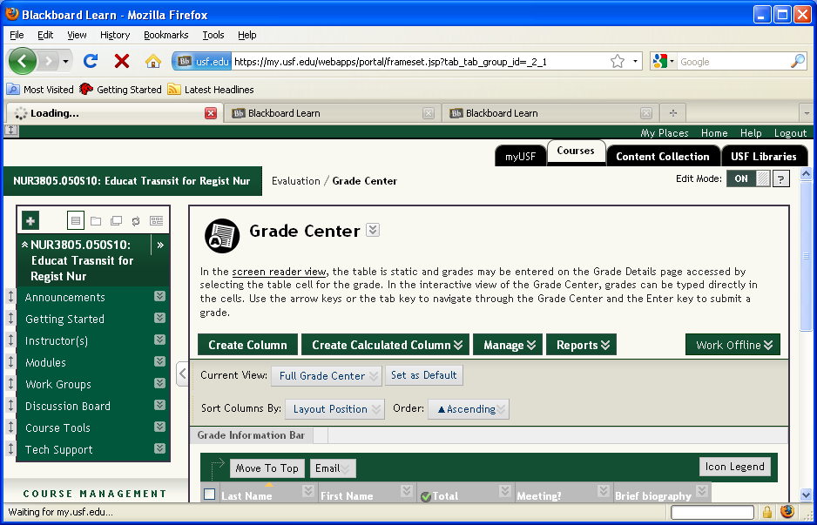

**From the Manage Drop-down window, select Smart Views.Slide 18 - Slide 18**

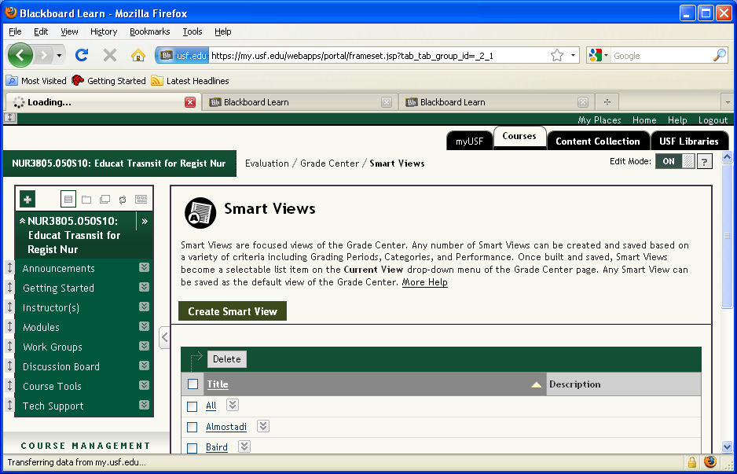

**To set up a Smart View, click Create Smart ViewSlide 19 - Slide 19**

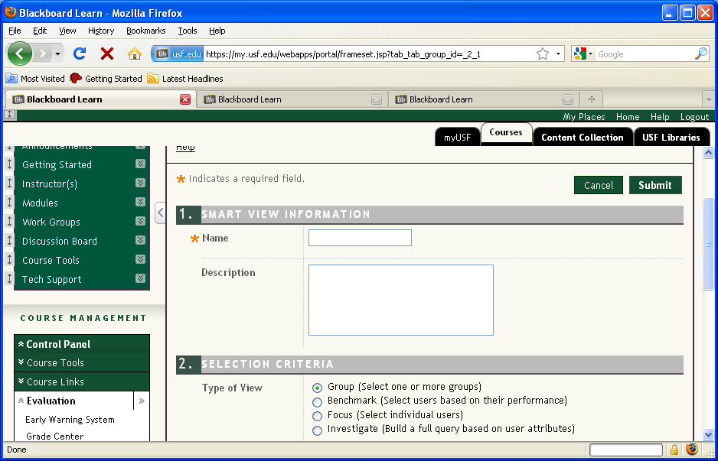

**Enter the name and if desired, a description of the view. Use the selection criteria identified here to forcus your smart view.Slide 20 - Slide 20**

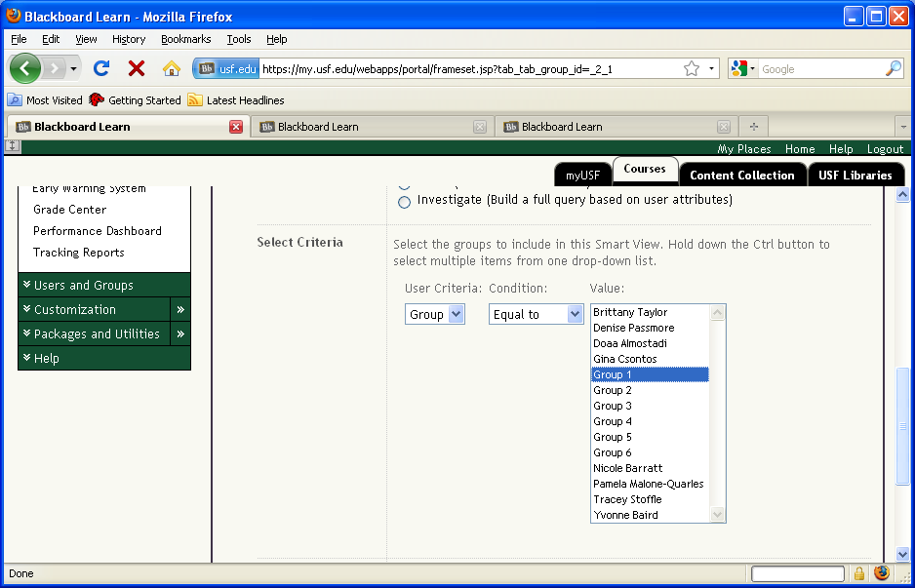

**In this example, we are setting up a smart view by group, so we selected Group 1 as the value for the smart view. After making your selection, click Submit.Slide 21 - Slide 21**

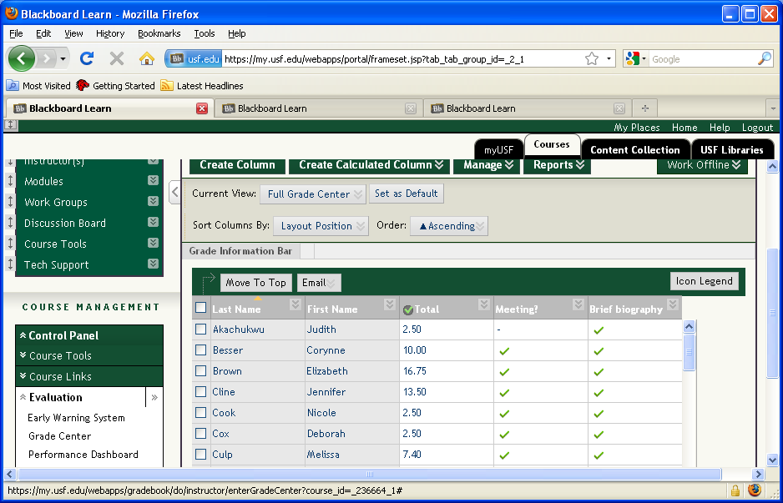

**To view only the students in Group 1, mouse over the Current view: (Note the default is Full Grade Center)Slide 22 - Slide 22**

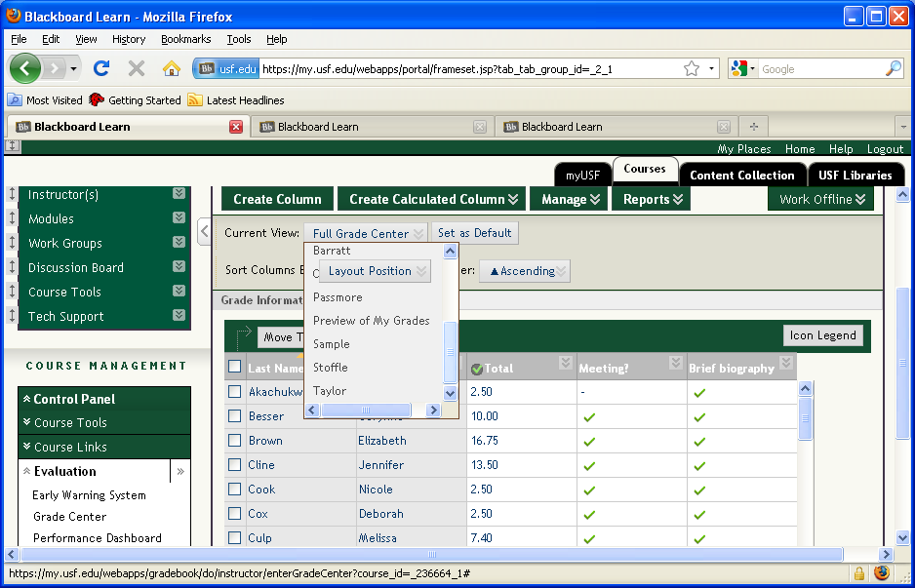

**From the list of smart views, select the view you want (In this example, it is Sample).Slide 23 - Slide 23**

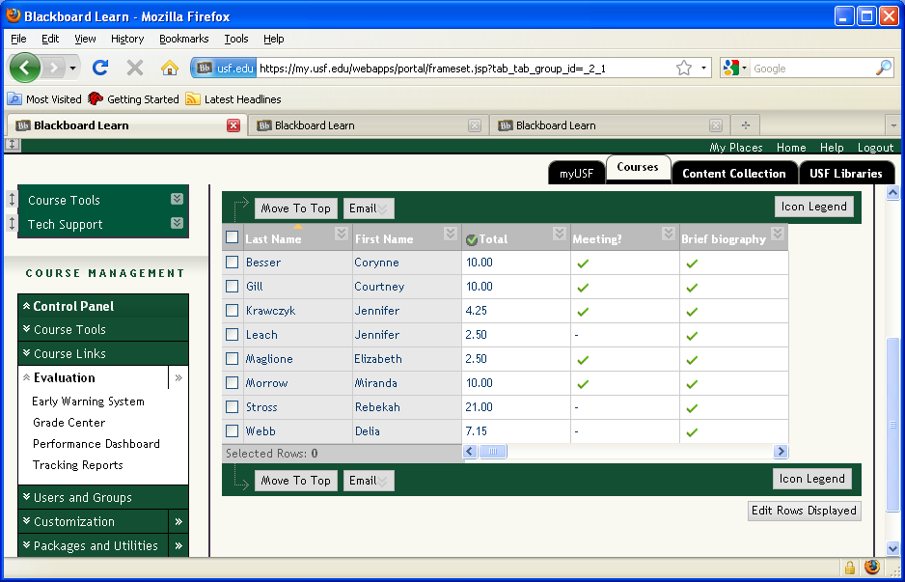

Now only the students identified in Group 1 display in the grade center.