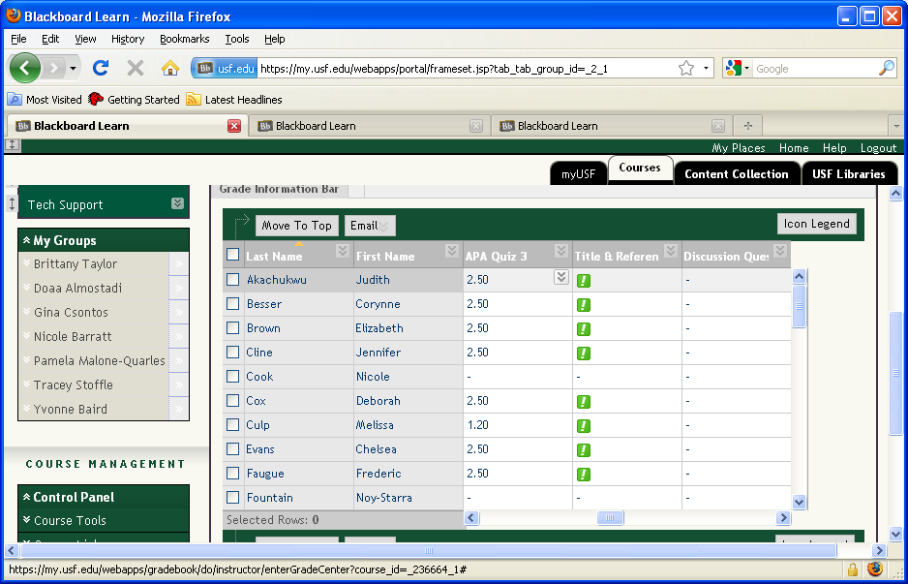

**From the Grade Center, go to the Assignment. In this case “Title & Reference”Slide 2 - Slide 2**

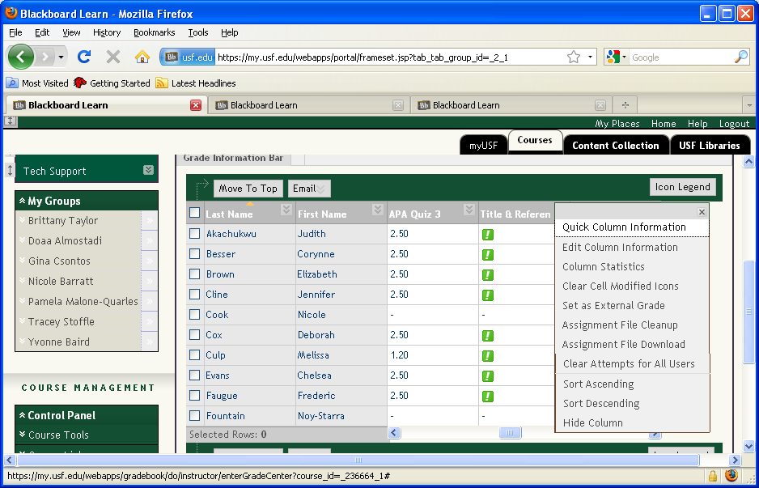

**To download multiple files into a zip document, select the drop-down box next to the title and from the box, select Assignment File Download.**

**Slide 4 - Slide 4**

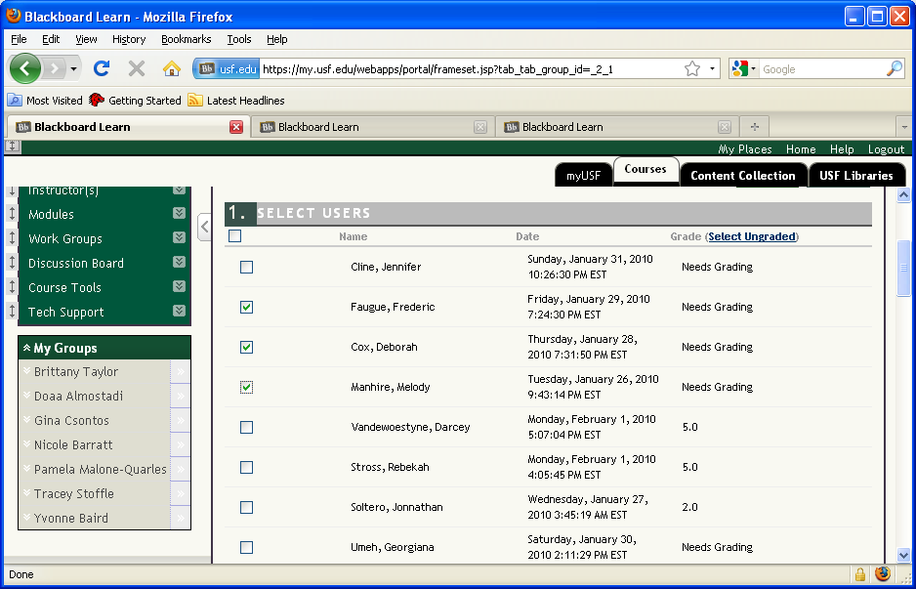

**Put a check next to the names you want to download and click Submit. Note that BlackBoard adds the assignment and student name to the file when it is downloaded this way.**

**Slide 6 - Slide 6**

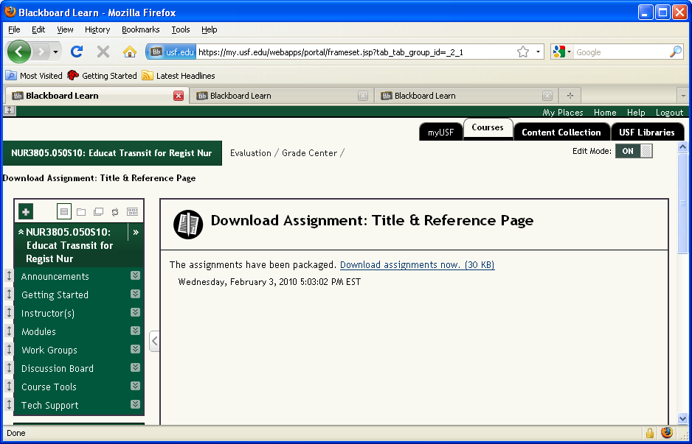

**Click the link to download the files you selected in a zipped document. This is good method if you have a lot of documents to download.**

**Slide 9 - Slide 9**

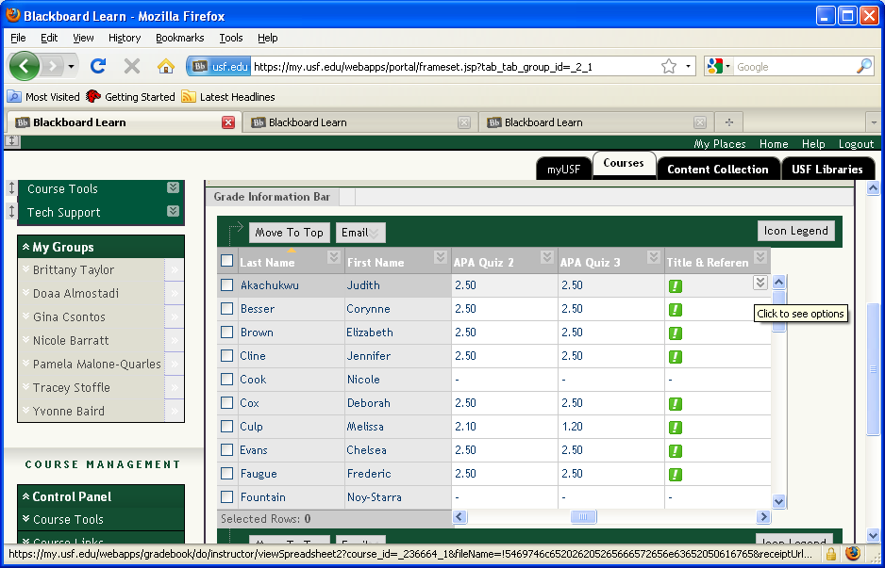

**However, if you want to open only one document at a time OR to upload corrected documents, move your mouse over the green ! to display the drop-down box shown next to the first name above.Slide 10 - Slide 10**

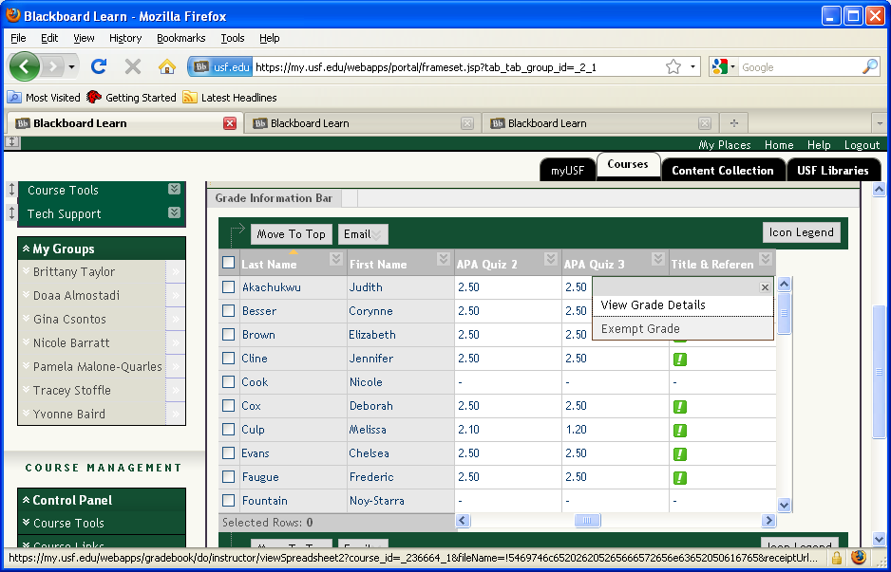

**Click the drop-down arrow and select View Grade Details.Slide 11 - Slide 11**

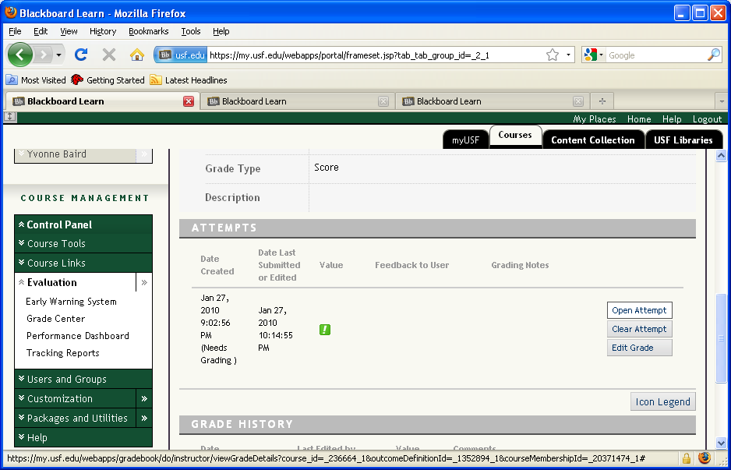

**Select Open Attempt to view the assignment.Slide 12 - Slide 12**

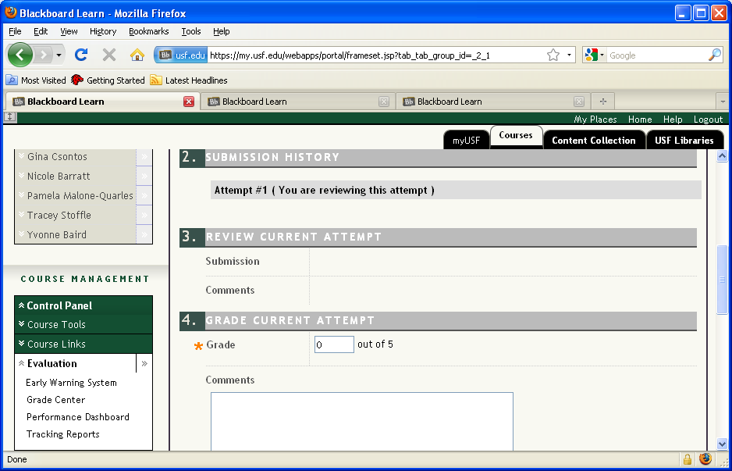

**Unfortunately, this student’s paper was not uploaded correctly as you can see the Submission field is blank. Many students do this because they forget the Attach File step. Tell the students to resubmit and use the instructions found in Modules>Week 1.Slide 13 - Slide 13**

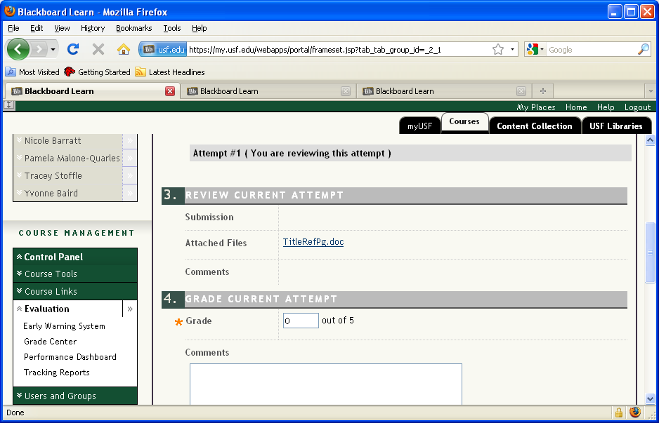

**The next student has successfully submitted her assignment as shown above. To download this paper, click the link.Slide 14 - Slide 14**

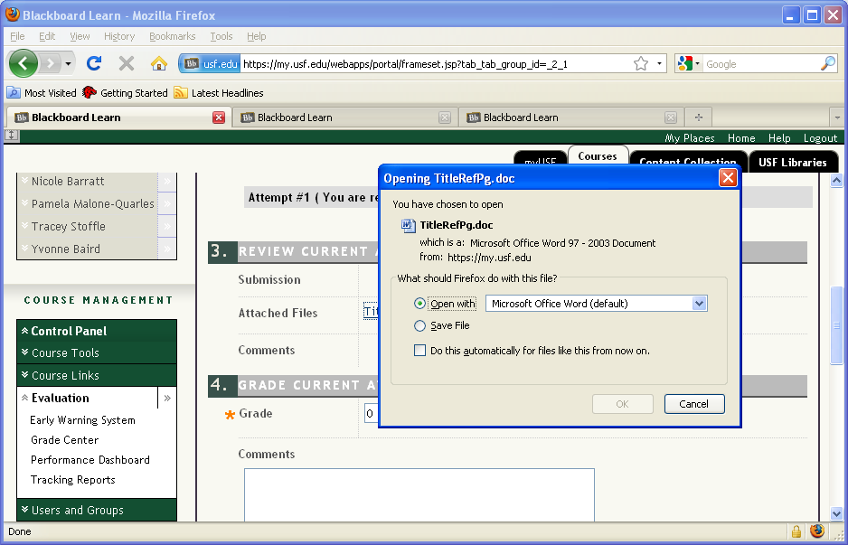

**You can either save the file to your computer or Open it with MS Office.**

**Slide 17 - Slide 17**

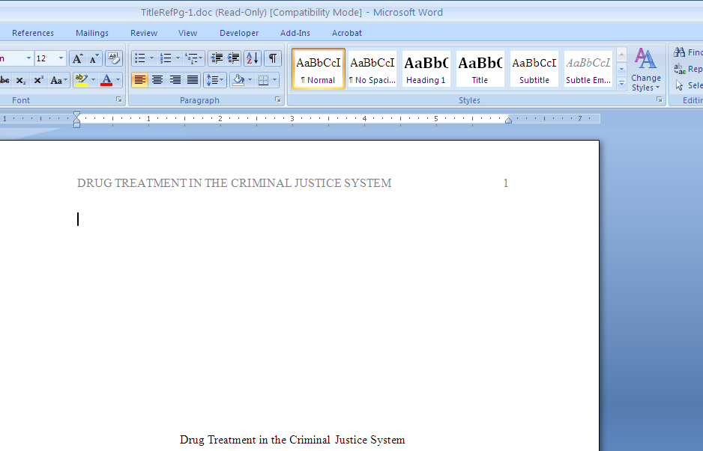

**From the menu across the top, click the Review button.Slide 18 - Slide 18**

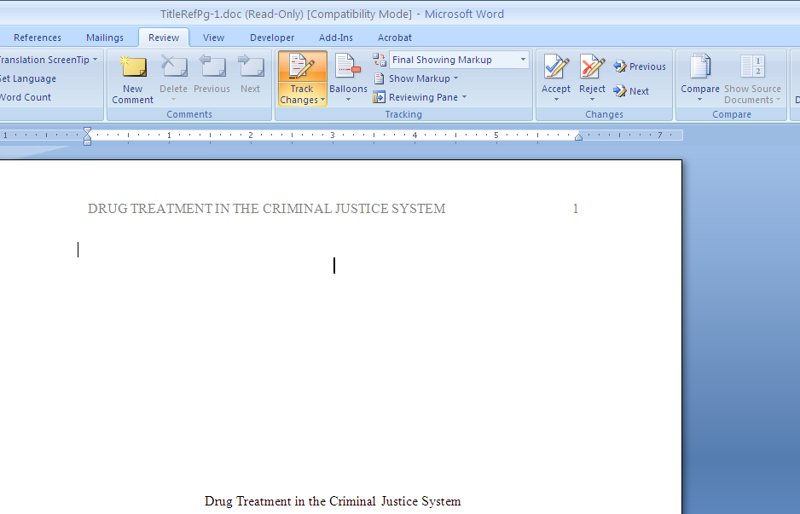

**Click Track Changes so that when you make marks on the paper the student will be able to see what was wrong.**

**Slide 20 - Slide 20**

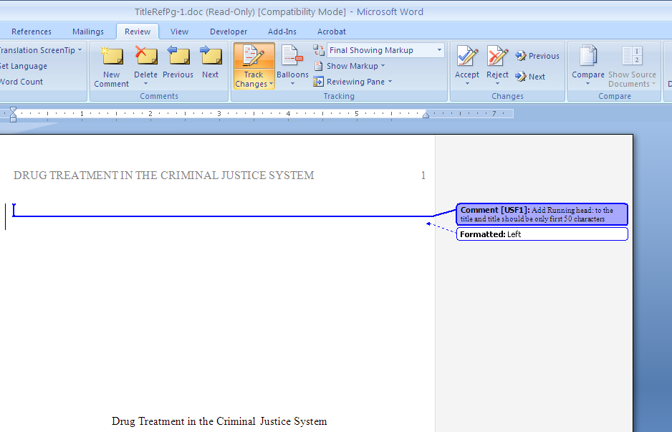

**To add a comment, click the New Comment button. In this case, the student did not do the header correctly.**

**Slide 22 - Slide 22**

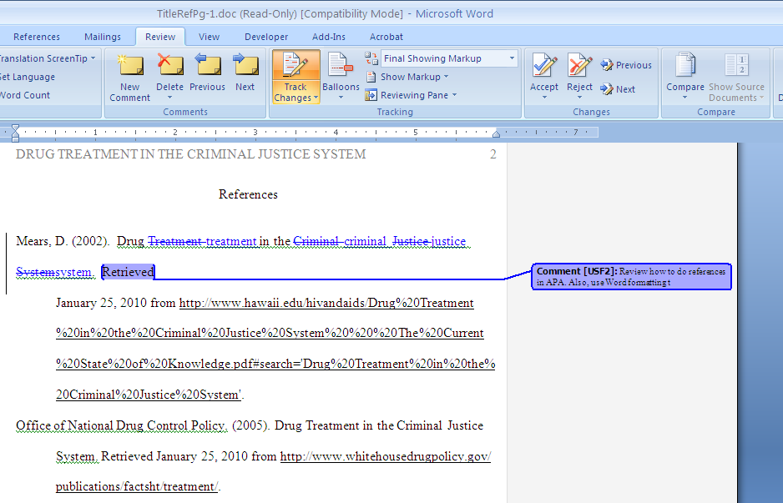

**With the Track Changes on, the changes made here are recorded for the student to see. In this case, the article title was not capitalized correctly. A comment was added reminding the student to review APA formatting.Slide 23 - Slide 23**

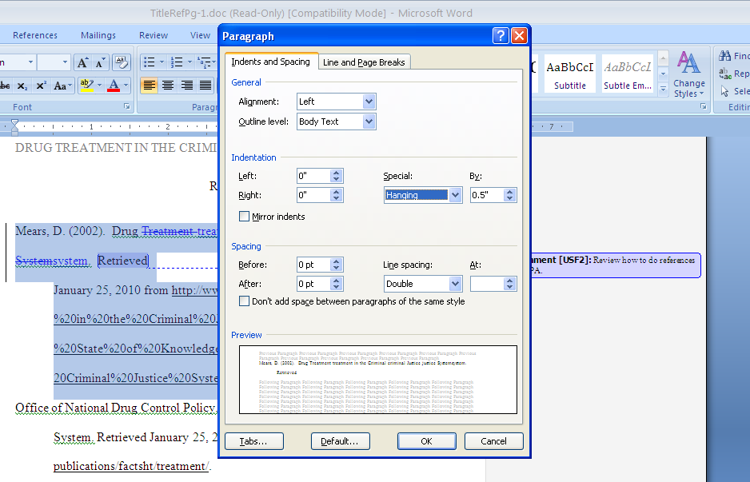

**Additionally, the student is using hard returns and tabbing so I formatted the paragraph.Slide 24 - Slide 24**

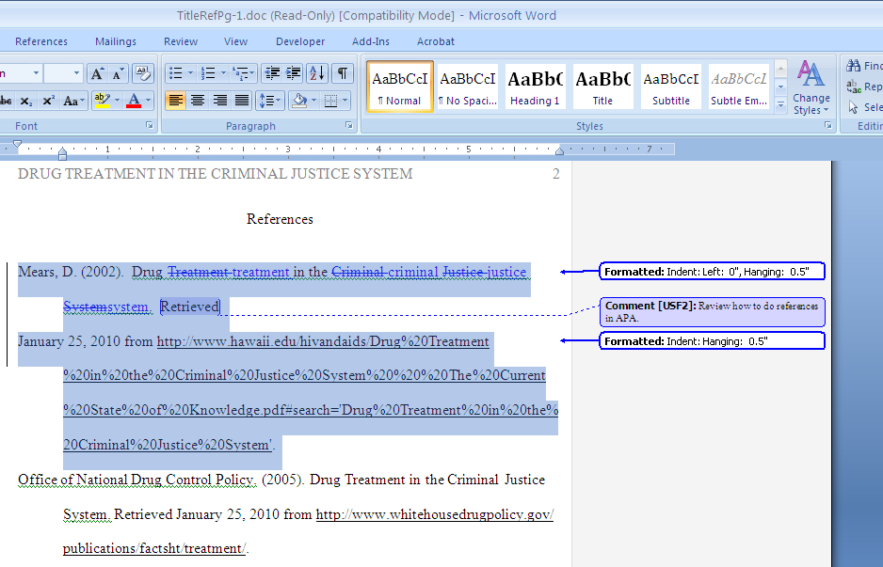

**The formatting note also displays in the margin.**

**When you have completed your review, save the document to your computer.Slide 28 - Slide 28**

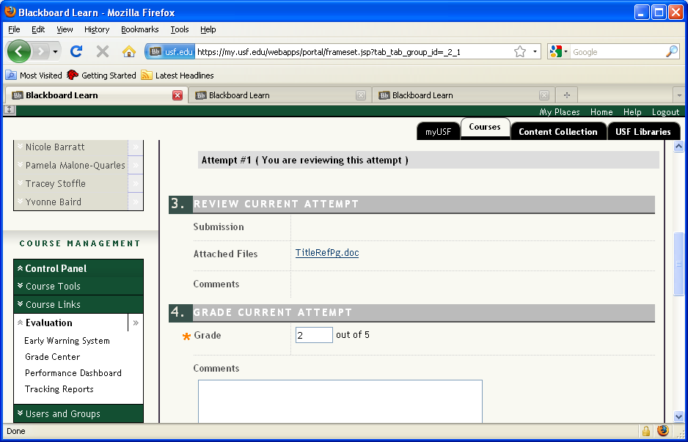

**Return to BlackBoard and assign a grade. Because this student missed three things, I gave only 2 points.Slide 29 - Slide 29**

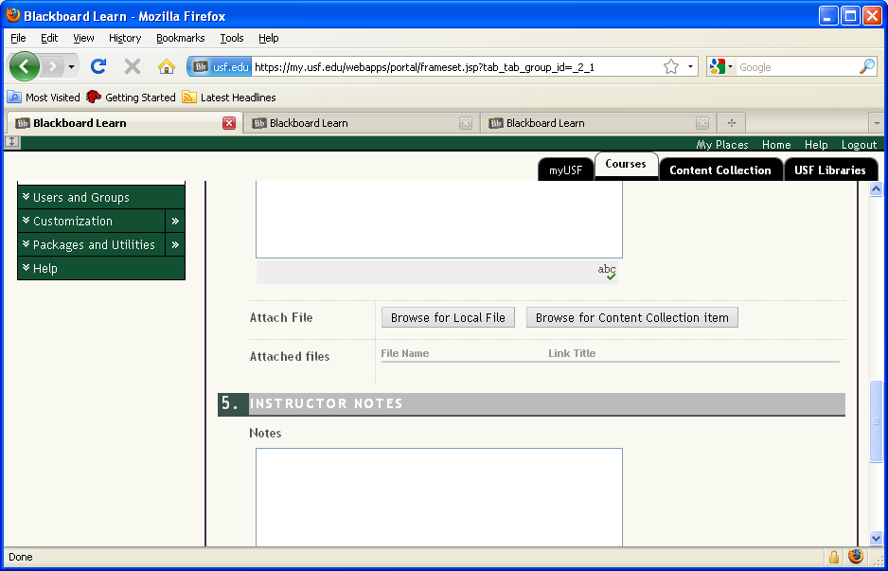

**So the student will know what was done wrong, click the Browse for Local File button to return the graded paper to the student.Slide 30 - Slide 30**

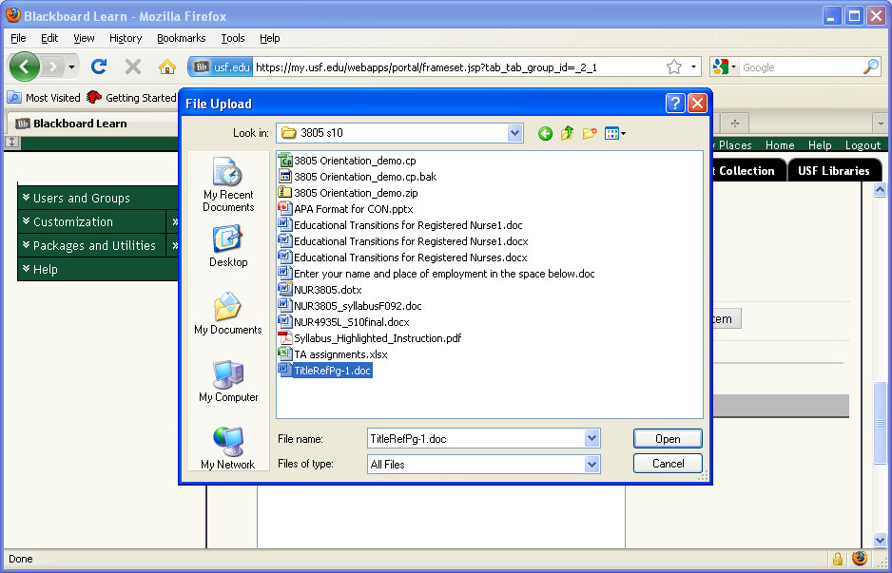

**Select the document from your computer and click Open.Slide 31 - Slide 31**

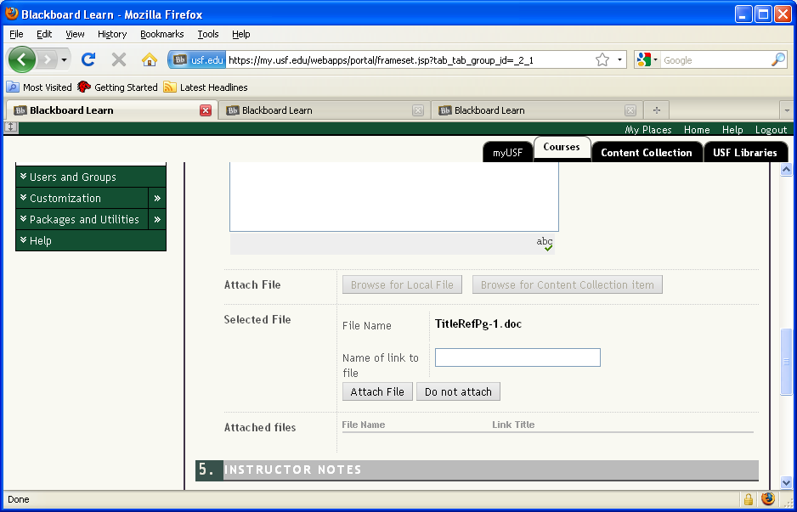

**Next, click the Attach File button.Slide 32 - Slide 32**

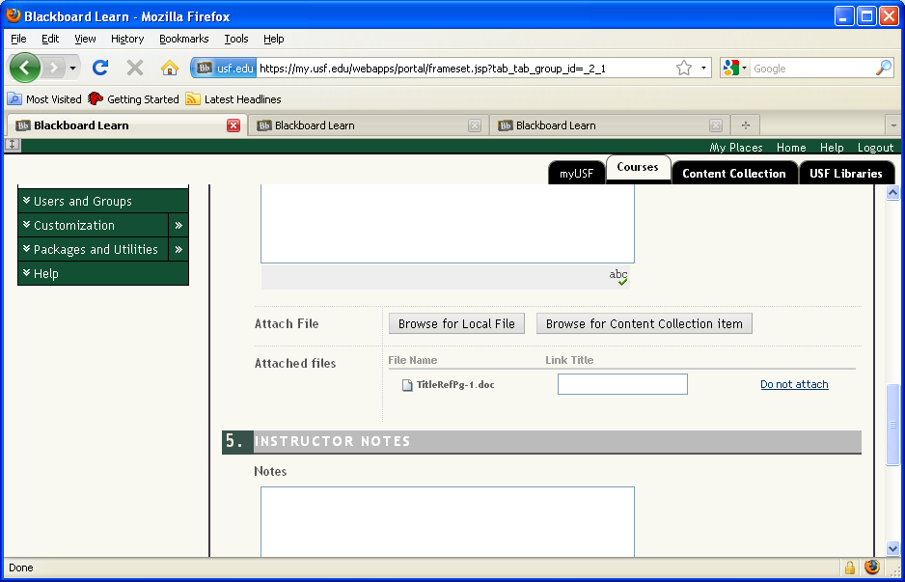

**The file name displays under the Attached Files heading. If it is not listed here, the file will not upload to BlackBoard.Slide 33 - Slide 33**

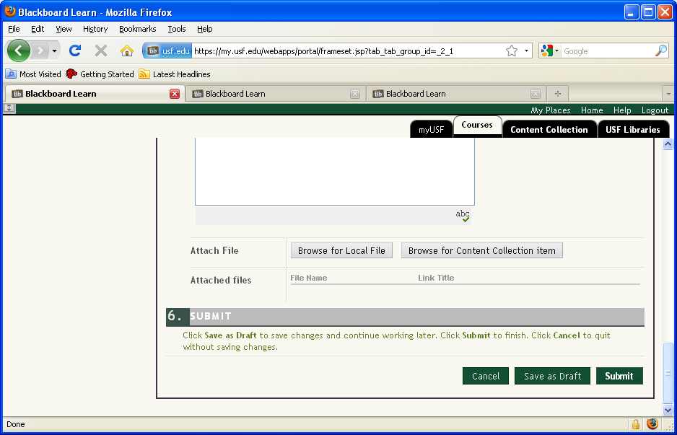

Click Submit to upload the document.