**USE THESE STEPS TO DOWNLOAD STUDENT PAPERS IF YOU WANT TO DOWNLOAD ONE PAPER AT A TIME, USE THE INSTRUCTIONS BEGINNING ON PAGE 7 OF THIS DOCUMENT.**

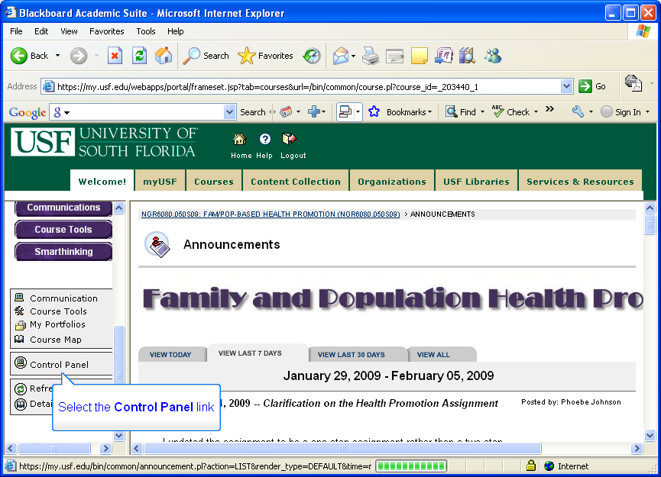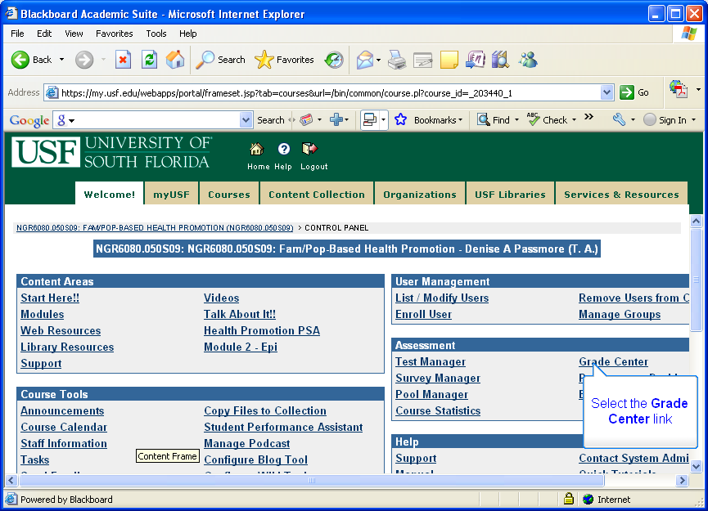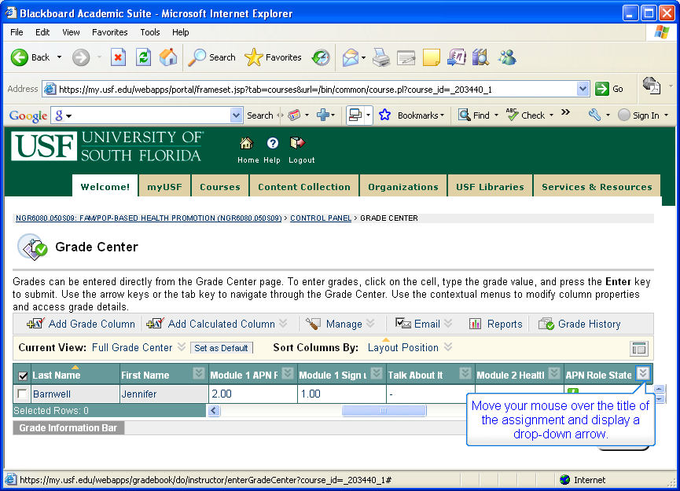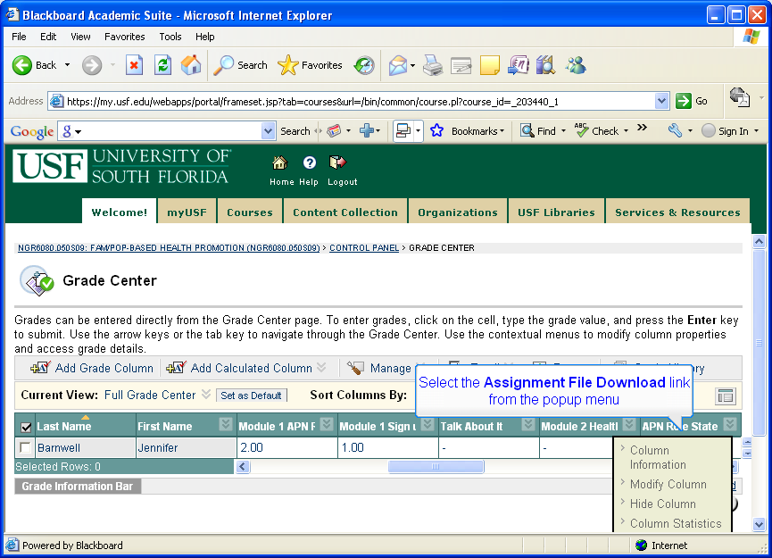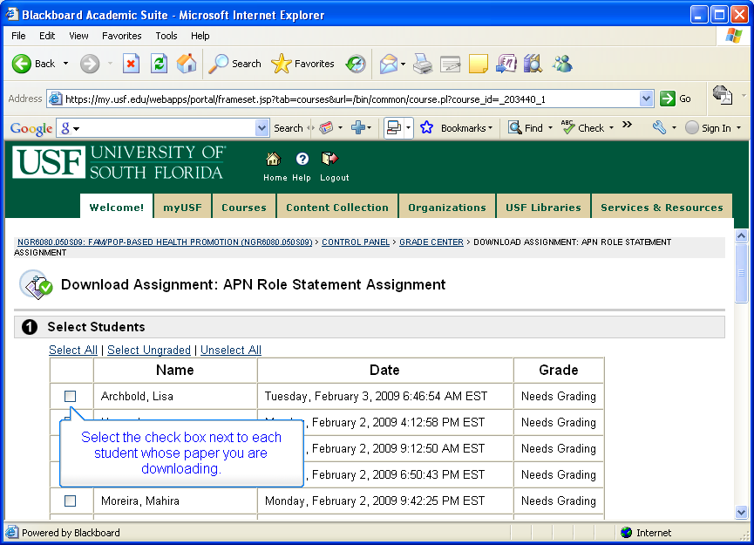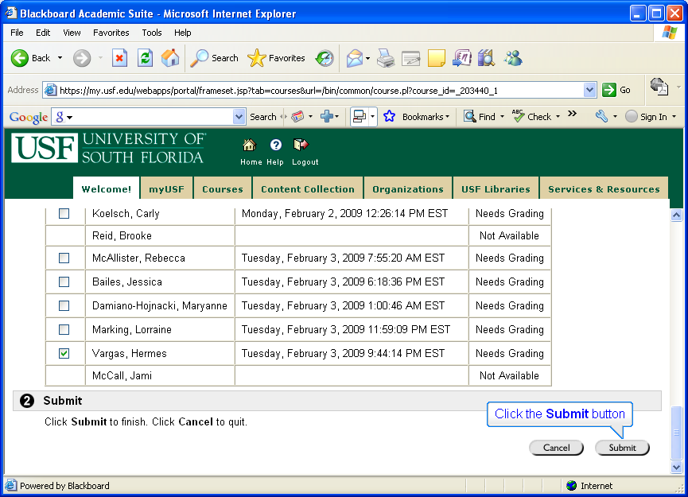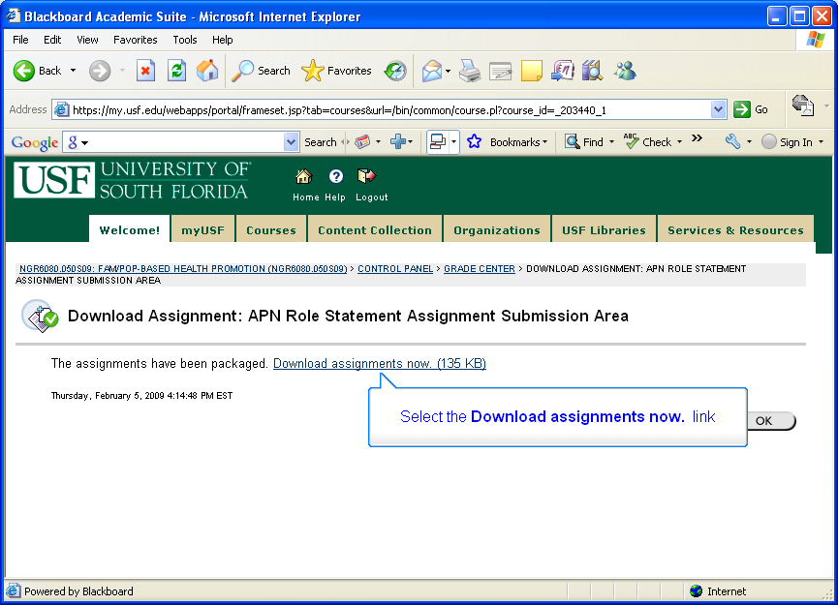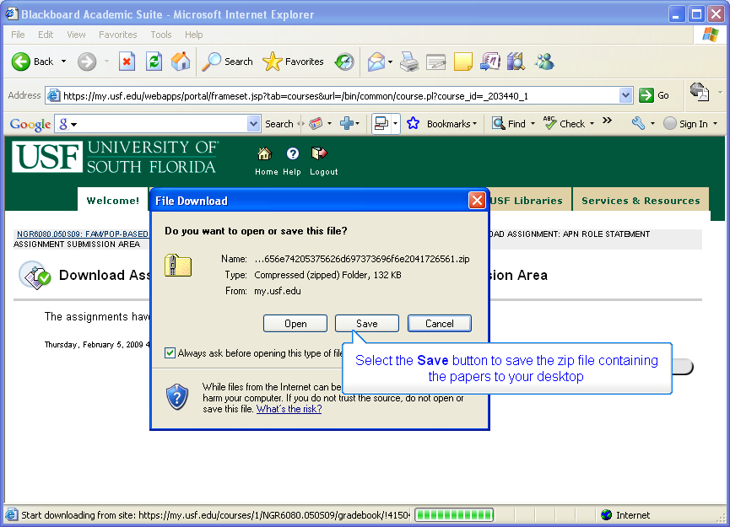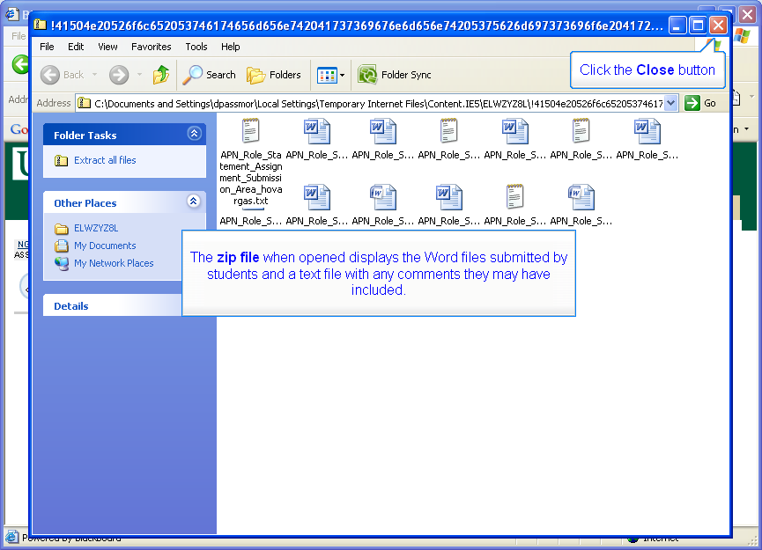

**USE THESE STEPS TO GRADE, MAKE COMMENTS AND/OR UPLOAD STUDENT PAPERS**

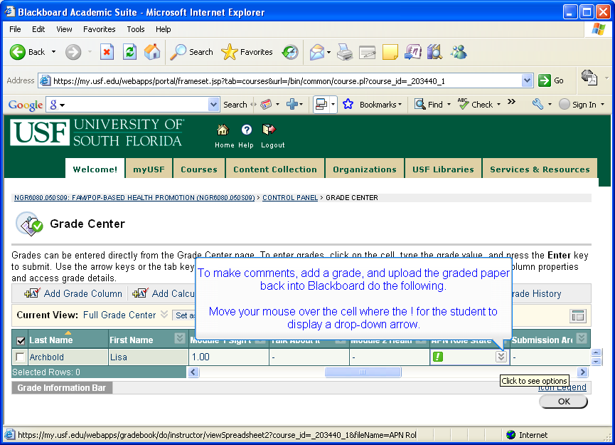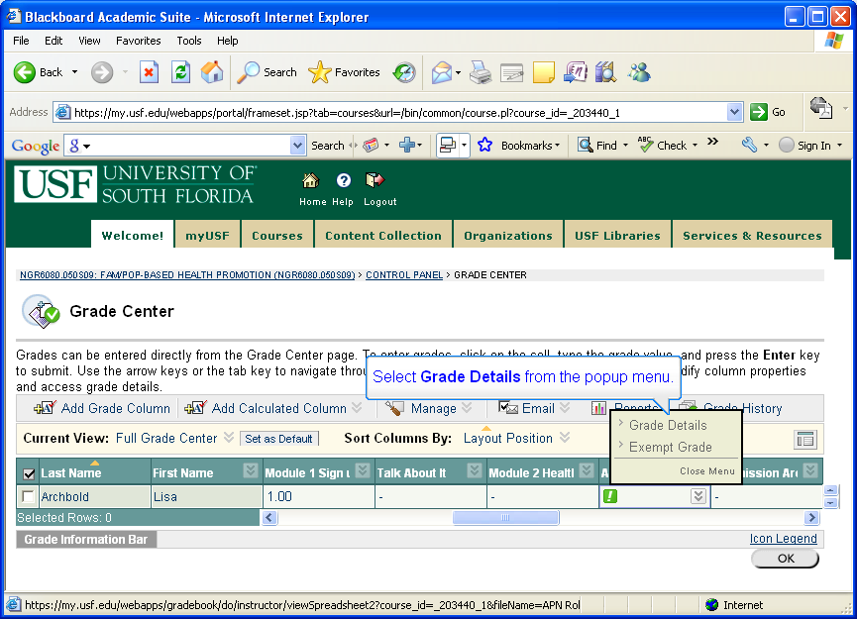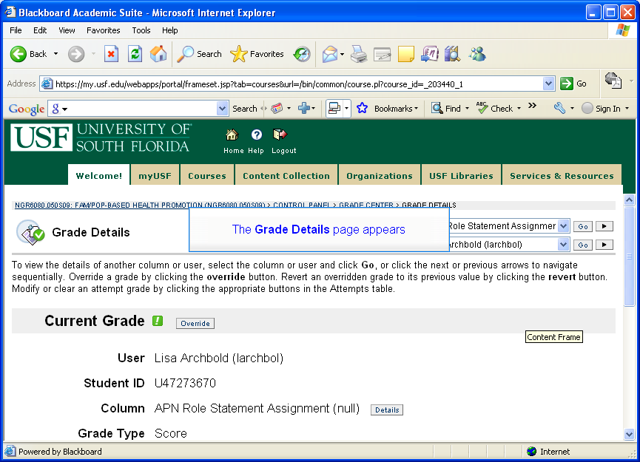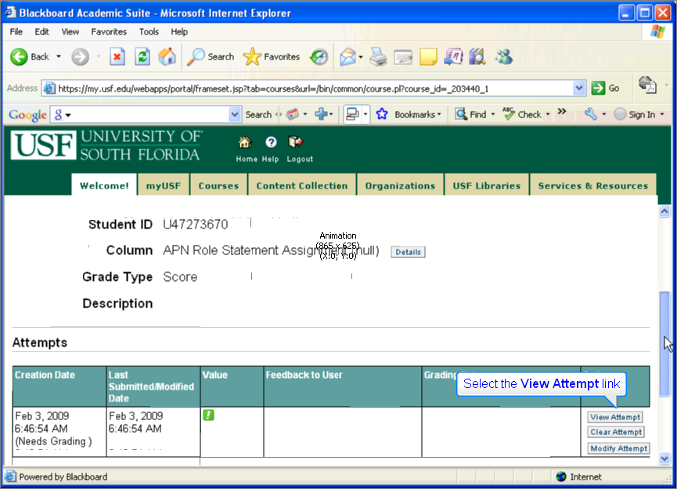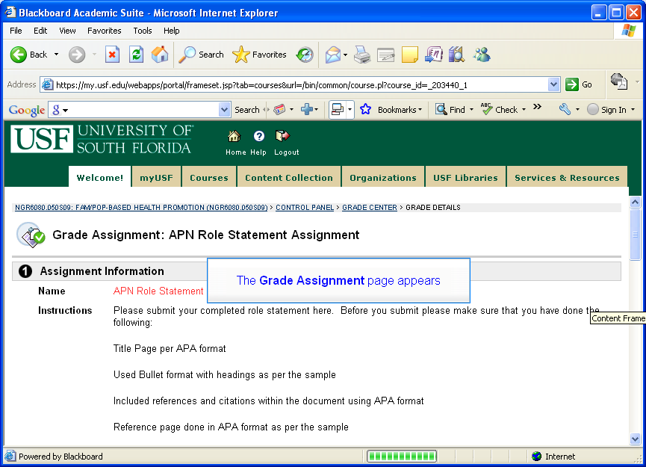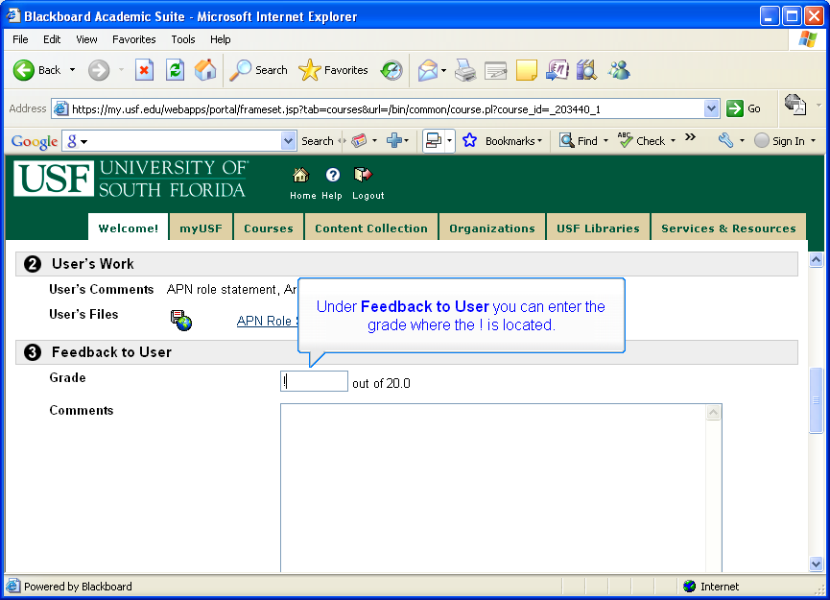

**NOTE: IF YOU WANT TO DOWNLOAD THE PAPERS ONE AT A TIME, WHEN YOU GET TO THIS STEP, CLICK ON THE INDIVIDUAL’S PAPER THEN SELECT SAVE FROM THE POPUP BOX THAT DISPLAYS. IF YOU ARE JUST GOING TO READ AND NOT COMMENT ON THE PAPER, YOU CAN SELECT OPEN.**

